My Family Cookbook
2020

YOUR NAME

Contents | Introduction 3  Spicy Biryani 5  Dish 2 6  Dish 3 7  Dish 4 8
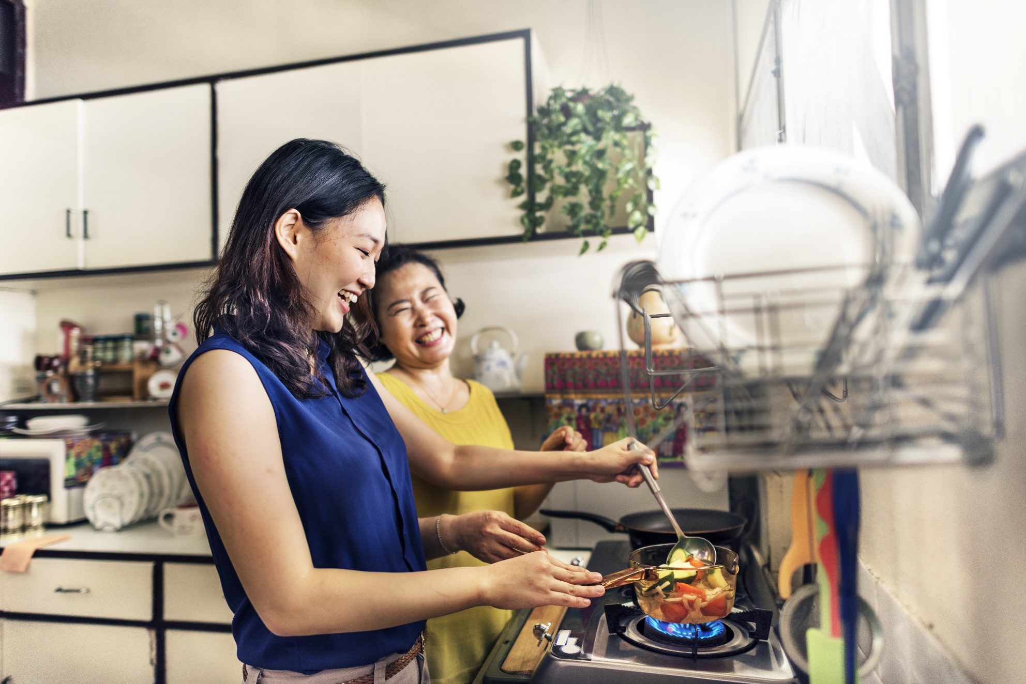

Introduction

Use this space to write something personal about your cookbook journey.

A delight of Subcontinent…  Spicy Biryani |  | Servings: 04  Preparation time: 60 minutes  Cook time: 40 minutes

Introduce your dish! Is it a family favourite? Is it inspired by a past holiday? Is it a family recipe?

 | Ingredients |  | Directions
 | List your ingredients here |  | - Stage 1  - Stage 2  - Stage 3  - Stage 4
Amazingly the best  Dish 2 |  |  |  |  | Servings: 04  Preparation time: 60 minutes  Cook time: 40 minutes

Introduce your dish! Is it a family favourite? Is it inspired by a past holiday? Is it a family recipe?

 | Ingredients |  | Directions
 | List your ingredients here: |  | - Stage 1  - Stage 2  - Stage 3  - Stage 4
Low cost & high taste...  Dish 3 |  |  |  |  | Servings: 04  Preparation time: 60 minutes  Cook time: 40 minutes

On the Insert tab, the galleries include items that are designed to coordinate with the overall look of your document. You can use these galleries to insert tables, headers, footers, lists, cover pages, and other document building blocks.

 | Ingredients |  | Directions
 | List your ingredients here |  | - Stage 1  - Stage 2  - Stage 3  - Stage 4
Tastiest & healthiest…  Dish 4 |  |  |  |  | Servings: 04  Preparation time: 60 minutes  Cook time: 40 minutes

Introduce your dish! Is it a family favourite? Is it inspired by a past holiday? Is it a family recipe?

Ingredients |  | Directions
List your ingredients here: |  | - Stage 1  - Stage 2  - Stage 3  - Stage 4

